NEST

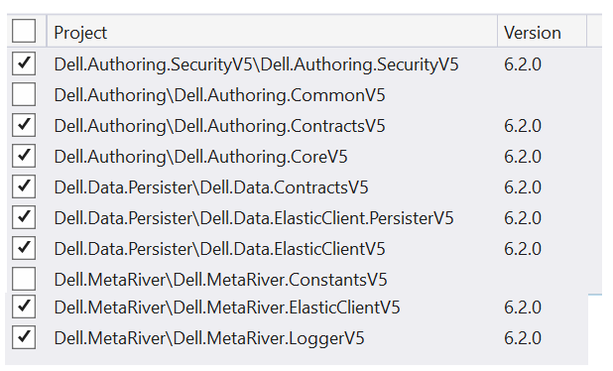

NEST.JsonSerializer

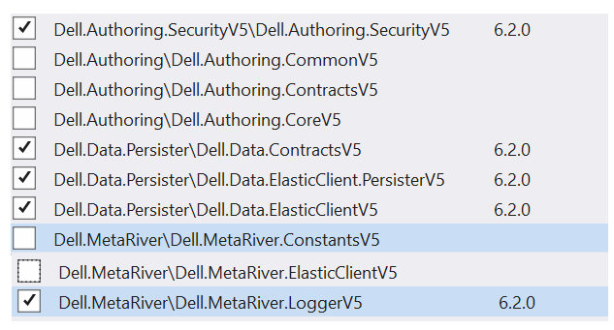

NewtoSoft.Json

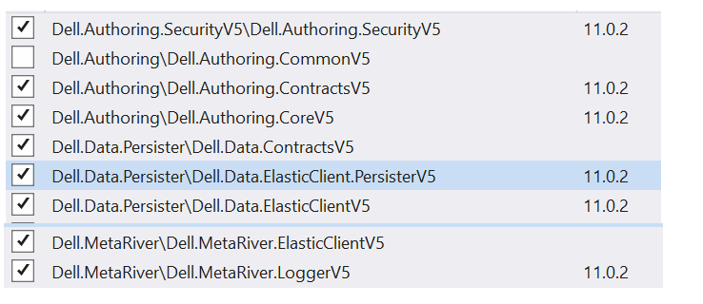

Microsoft.Extensions.Configuration.Json

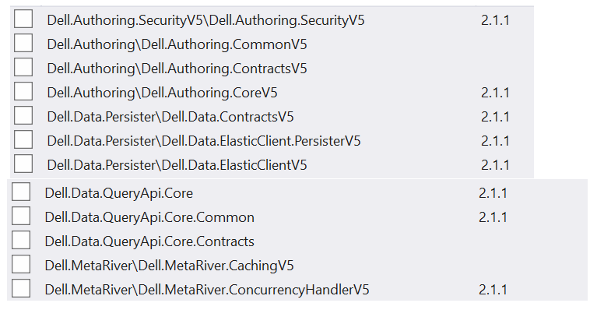

Log4net.ElasticSearch.Async

